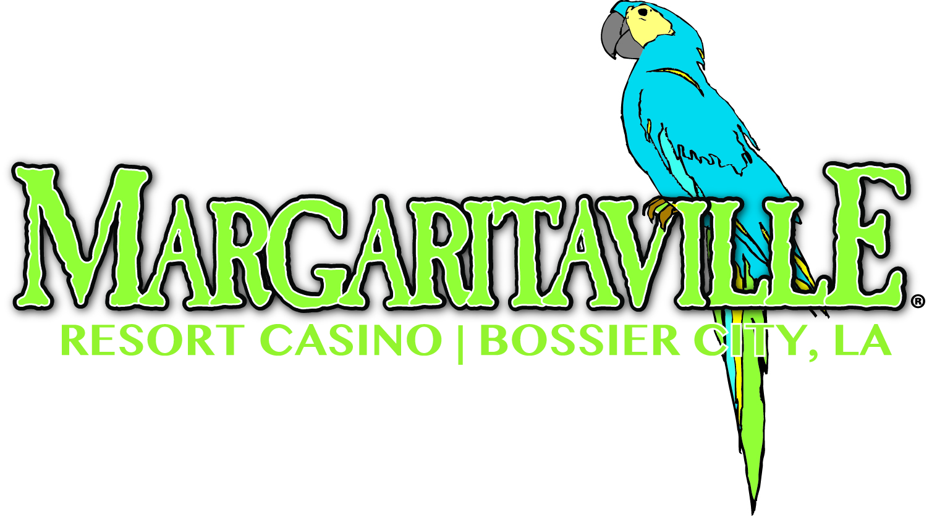

REQUEST FOR WIN LOSS

Year:

Name:
Players Card #:

Address:

Phone Number: ( )

Signature: Date:

Please mail or fax completed form to:
Margaritaville Resort Casino
Attention: Win/Loss
P.O. Box 5456
Bossier City, LA 71171
Fax Number (318) 562-4999

